* Sensor voltage is multiple by 100

1. init
   1. Display line 0: "initializing"
   2. Read sensor for 1 second and set vSensor to average
   3. a=20.9/vSensor
   4. Display Line 0: "Status 20.9%=" vSensor vsensor/100 "%"
2. loop
   1. read sensor as vSensor
   2. display Line1: "Current:" vSensor\*a "%" vSensor/100 "mv"

None inverting op-amp:

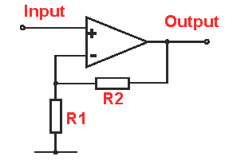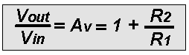

* Resistor 1k
* Potentiometer 200k
* Lm321 op amp
* LCD
* Arduino
* Power plug
* Mono audio plug